Prague, 5 March 2019

DO YOU WISH TO WATCH A HIGH QUALITY EUROPEAN FILM?
THE 26TH ANNUAL EDITION OF DAYS OF EUROPEAN FILM
STARTS IN A MONTH!

Prague, 4 – 11 April / Lucerna, Světozor and Kino Pilotů cinemas
Brno, 4 - 7 April / Scala cinema

Echoes will take place in the following towns and on the following dates:
Havířov (15 – 17 April), Hodonín (16 – 17 April), Boskovice (15 – 16 April), Červený Kostelec (16 and 18 April), Hradec Králové (15 – 17 April),
Jablonec nad Nisou (19 – 21 April)
____________________________________________________________________________________________________________

Days of European Film have been offering the most interesting films of contemporary European cinema for 26 years. This year, the festival invites the audience to cinemas to watch 45 films from various parts of Europe. The films, divided into traditional as well as completely new programme sections, cover the themes of ordinary life: sports, Nature, eroticism and love, music, and freedom of choice. With their festival programming, DEF want to be more accommodating to the audience. The festival will include seminars for cinema operators, film screenings for children and seniors, debates and special guests. But, above all, DEF invite the audience to see high-quality European films!

The 26th annual edition of Days of European Film will be opened on April 4th by the French film Edmond. The splendid costume comedic drama with a French charm tells the story of the poet and writer Edmond Rostand (Thomas Solivéres) who is given the chance of a lifetime as a poor artist – to write a theatre play. The film about the creation of one of the most beautiful and most performed theatre plays, Cyrano de Bergerac, shows the source of Rostand’s inspiration in real life. The film was also shot in the Czech Republic and the audience can thus recognise the Estates Theatre and other locations in the scenes. Edmond is in distribution in 26 countries and has been seen by 700,000 cinema-goers in France alone since its January premiere. Hana Šilarová, the DEF programmer, adds to the opening film: “The young Edmond Rostand is an insecure and incorrigibly romantic writer who waits for an opportunity in vain. However, over time, we watch him grow along with his magnum opus. Set in the period of the 19th century in Paris, this film reveals the source of Rostand’s inspiration used in his artistic creative process. The film includes situational humour and the well-known scene under a balcony.”

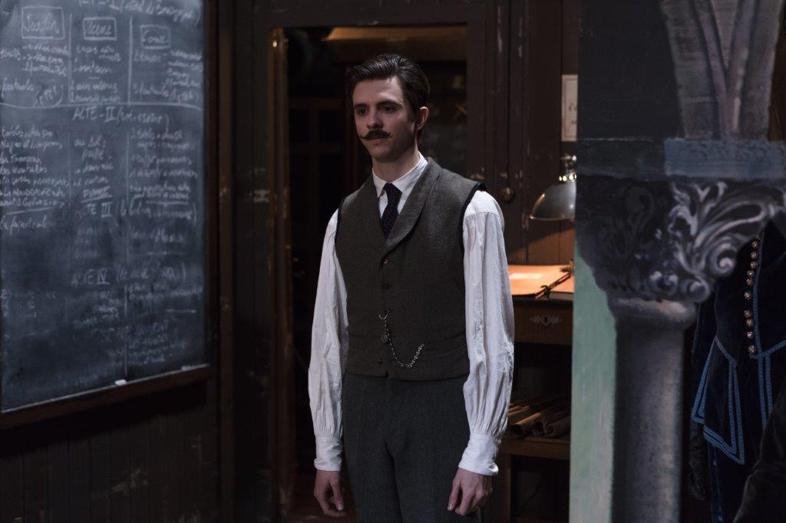
Thomas Solivéres as young Edmond Rostand and Simon Abkarian and Marc Andreoni
in the movie Edmond. Source: DEF

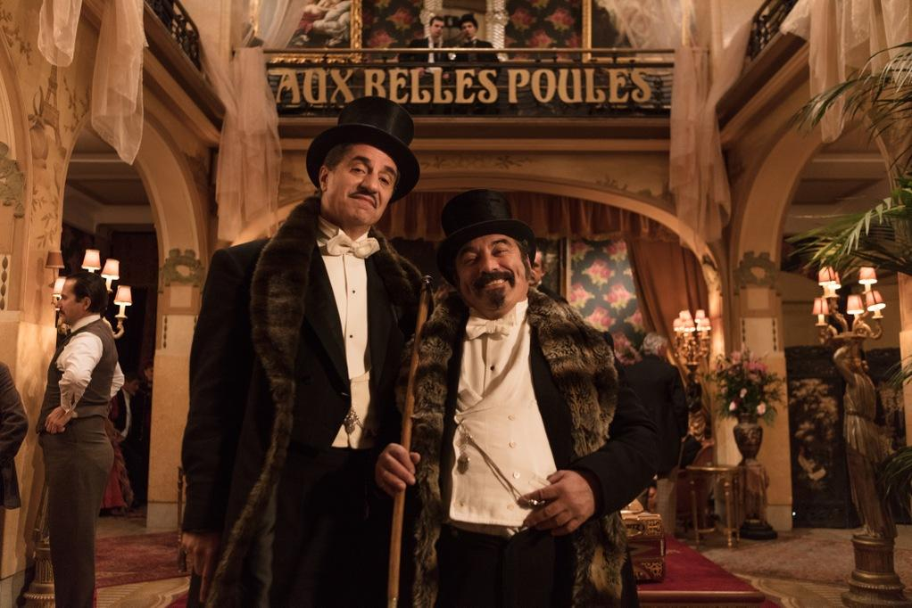
The 26th Days of European Film will offer the audience 45 films divided into 7 sections:

Best of / The selection of the most interesting films created over the last two years in the cinema of the respective European countries.
MEDIA: Love without Borders / The way to one’s heart is through film! And the films from this section will show the various forms of love, flirt and erotic tension in relationships between two (and among more) people.
Film & Music / This year’s DEF will once again follow the rhythm of music! This traditional section will present films with music themes – ranging from documentaries about music stars, through recorded operas to live action music films.
Mother Nature / Can an individual help Nature? Are state leaders capable of reaching agreement to avert the climatic change? Do we know how to treat animals? These are the themes of this new section with a focus on the planet Earth.
Eurosport / This new section concentrates on films with sports-related themes. It will offer amazing stories of top athletes and will show in documentaries how sports can help escape the everyday grey reality.
LUX Film Prize / This section presents the LUX Film Prize of the European Parliament and its three finalists, including the winning film.
To the Point: Freedom of Choice / The traditional section of the European Commission titled “To the Point” focuses on the theme of elections and the picture of political issues presented by the media. We have chosen both documentaries and live action films, which reflect the dynamically changing world of media and online world where it is possible to alter the reflection of reality as well as election results.

From among films by Czech producers, DEF will present a promising debut It Is Snowing! by Kristina Nedvědová, featuring Petra Nesvačilová, Vanda Hybnerová and Hana Vágnerová in leading roles. Planet Czechia, one of the most successful Czech documentaries has been included in the new Mother Nature section. The traditional section of the European Commission, this time focused on the election year, will present the film Breaking News by the director Tomáš Bojar. The Eurosport section will offer King Skate by Šimon Šafránek. The screenings of all these Czech films will be accompanied by debates with their creators.

The audience can find more detailed information on the films in the respective sections and on the accompanying programme as well as other information on the website at www.eurofilmfest.cz and at FB DEF.
We also cordially invite you to a PRESS CONFERENCE that will take place in the Riding Hall (Konírna) of the Nostic Palace on Tuesday 26 March 2019 from 11.00 a.m. (the Ministry of Culture, Maltézské náměstí 1, Praha 1). You can find more information in the attached invitation card. We will provide you with information on the presence of guests from among creators at the press conference sufficiently in advance.

____________________________________________________________________________________________________________
THE FESTIVAL TAKES PLACE UNDER THE AUSPICES OF THE CZECH CULTURE MINISTER ANTONÍN STANĚK, THE REPRESENTATION OF THE EUROPEAN COMMISSION IN THE CZECH REPUBLIC, ZDENĚK HŘIB – THE LORD MAYOR OF THE CAPITAL CITY OF PRAGUE, MARKÉTA VAŇKOVÁ – THE LORD MAYOR OF THE STATUTORY CITY OF BRNO, AND PAVEL ČIŽINSKÝ – THE MAYOR OF THE CITY DISTRICT OF PRAGUE 1 / ORGANISED BY THE EMBASSIES AND CULTURAL INSTITUTES OF EUROPEAN COUNTRIES AND BY THE REPRESENTATION OF THE EUROPEAN COMMISSION IN THE CZECH REPUBLIC / WITH THE SUPPORT OF THE MINISTRY OF CULTURE OF THE CZECH REPUBLIC, THE CAPITAL CITY OF PRAGUE, THE STATUTORY CITY OF BRNO, AND THE CITY DISTRICT OF PRAGUE 1
THE MAIN PARTNER IS THE AXOCOM MEDIA COMPANY / THE MAIN MEDIA PARTNER IS THE CZECH TELEVISION / THE MEDIA PARTNERS ARE ČSFD.CZ, RESPEKT, AKTUÁLNĚ.CZ, PROTIŠEDI.CZ AND EXPATS.CZ
Contact:
Michaela Dvořáková, PR DEF
Tel.: +420 732 372 424
Email: pr.michaeladvorakova@gmail.com
Web: www.eurofilmfest.cz

